Small Grants Program
2022-2023

This Small Grants Program is one part of an Economic Development Toolbox that is the framework for public investments intended to leverage significant private investment in downtown Burlington. The grants programs are informed by the recommendations from the 2008 Downtown Burlington Master Plan (Haden Stanziale, et al.); from research into the types of programs offered in communities across North Carolina, and from conversations with individual business and property owners in downtown Burlington.

The Burlington Downtown Corporation (BDC) is committed to using the funds to leverage new investment to provide gap funding for projects that show the most potential for strengthening downtown Burlington’s economy in the long term. Business needs were identified through market analysis using ESRI market data, stakeholder input, and visioning completed as part of the 2008 Burlington Downtown Master Plan, and survey and interview data collected from downtown business owners.

PROGRAM GOALS
With downtown Burlington’s particular needs in mind, the Small Grants Program focuses on the following goals:
- To stimulate the development of the Municipal Service District (MSD) through the priorities identified in the BDC Plan of Work for FY 2022-2023 (i.e., innovative businesses, residential, retail, service sector, restaurant and other uses identified in market analyses and by the BDC as desirable to future downtown success),
- To facilitate the sustainability and strengthening of both new and existing businesses (i.e., suggest business plan consultation prior to application); and
- To facilitate the rehabilitation and modernization of downtown buildings into 21st century business locations, being sensitive to historic preservation.

IMPORTANT PROGRAM REQUIREMENT HIGHLIGHTS

- All programs provide matching grants that require a 50-50 match by the applicant and are structured as deferred loans, which means that if the improvements stay in place for a period of three years the interest-free loan becomes a grant. However, if the business or property closes or changes hands, the appropriately pro-rated portion of the loans becomes due to the BDC.
- Funds are disbursed as reimbursements for completed work by submitting PAID invoices to the BDC.
- If awarded funds for a project, applicant must complete project work within one year of award date, unless an extension is requested in writing and granted.
- Pre-application meetings with BDC staff are required.
- Property owner applicants may be eligible to apply for funding in multiple categories (this can be determined during the pre-application meeting). If planning to apply in multiple categories, the applicant must submit one application for each category.
- Incomplete applications may not be accepted at the BDC Grants Committee’s discretion.

GENERAL PROGRAM INFORMATION

ELIGIBILITY
Downtown Property and/or Business Owners located within the boundaries of the downtown Municipal Service District (MSD) are eligible to apply for the BDC Small Grants Program. Properties located inside the boundaries of Webb Ave., Lexington Ave., Morehead St., and Church St. are considered part of the MSD. Please see the map below:

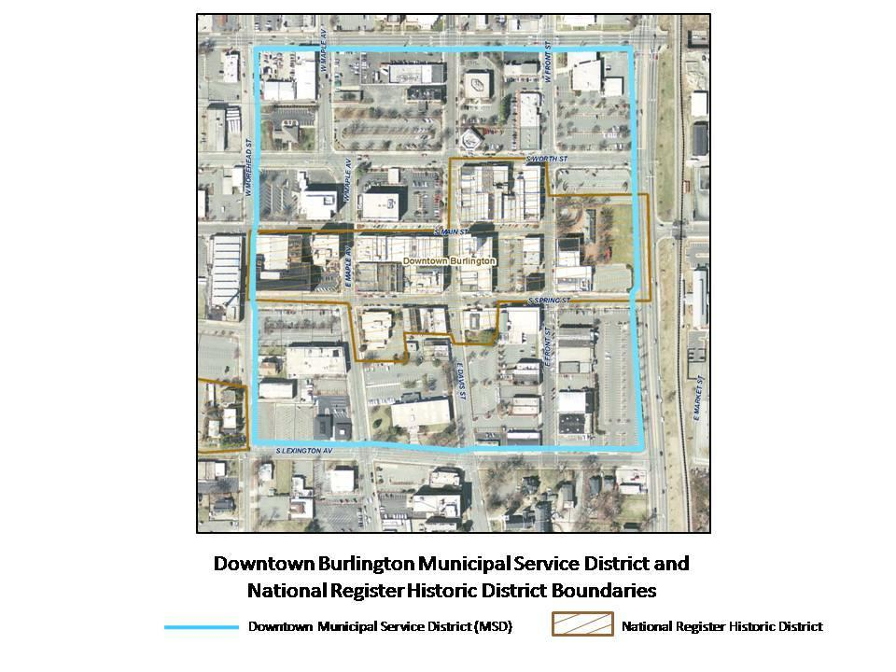

GRANT CYCLE SCHEDULE
The BDC’s Grant Program is administered on a quarterly basis. Grant applications are due for the 2022-2023 grant cycle no later than midnight on the dates indicated below, in order to be considered for that quarter’s granting cycle. Pre-application meeting scheduling is available approximately one month prior to each quarter’s application due date. Applicants are required to have a pre-application meeting with BDC staff.

QUARTER | PRE-APP MEETING SCHEDULING  OPEN | APPLICATION DEADLINE | NOTIFICATION  DATE
1st | June 15th | July 15th | August
2nd | Sep. 1st | Oct. 1st | November
3rd | Dec. 1st | Jan. 1st | February
4th | March 1st | April 1st | May

FUNDING SOURCE & AVAILABILITY
- The grants in this funding cycle are matching grants that require a 50-50 match by the applicant and are structured as deferred loans, which means that if the improvements stay in place for a period of three years the interest-free loan becomes a grant. However, if the business or property closes or changes hands, the appropriately pro-rated portion of the loans becomes due to the BDC.

- This Small Grants Program is typically supported by funds from the City of Burlington General Fund and the Downtown Burlington Municipal Service District tax funds.
- Grants will be awarded for eligible projects on a funds-available basis and at the discretion of the Burlington Downtown Corporation Board of Directors based on recommendations from the Grants Review Committee.

SCORING METHODOLOGY
2022-2023 Grant Committee Scoring Process
Scores - 1 (Low) - 10 (High)

Criteria | Weight
Strength of Business Model | 30%
Investment Value and estimated BDC ROI | 20%
Potential to Influence Tax Value of Property | 15%
Business Demand/Desirability to Current Mix | 15%
Past Grant Funds Allocated to Property/Business (1 / 5 / 10) | 10%
Good Standing of Existing Business/Business Owner | 5%
Business Collaborator | 5%
Total Score | 100%
*Excluding “Past Grant Funds Allocated”

Grant award requires a minimum score requirement of 70%.

Criteria Descriptions:
Strength of Business Model: Creating a business model isn’t simply about completing your business plan or determining which products to pursue. It’s about mapping out how you will create ongoing value for your customers.
Investment Value and Estimated BDC ROI: Application will be scored based on the project’s total value in an effort to leverage the public investment as significantly as possible. The greater the anticipated return on the BDC’s investment, the higher the project will be scored under this criterion.

Potential to Influence Tax Value of Property: Attention will be given to projects that have the capacity to positively impact the property’s tax value and, in turn, increase the overall tax value of MSD properties overall.

Business Demand/Desirability to Current Mix: Each project will be scored according to how closely in-line it is with the BDC’s current business recruitment priorities.

Past Grant Funds Allocated to Property/Business: Preference will be given to new applicants over those who have previously been awarded a grant.

Good Standing of Existing Business/Business Owner: Applicant must be current with any required licensures, registrations, taxes, etc., in order to meet eligibility requirements.

Business Collaborator: A collaboration exists when multiple people/businesses pool their common interests, assets, and professional skill to promote and benefit the interests of downtown; product or service offered is in alignment with current downtown business mix.

INELIGIBLE COSTS
- Financing of existing debt, working capital, non-capital equipment, and inventory.
- Operation and maintenance costs:
  - Office equipment (i.e., technology, computers, furniture, office supplies, etc.);
  - Rent, utilities, including cable/internet service, or other recurring overhead costs;
  - Salaries, personnel expenses;
  - Emergency building repairs and routine maintenance;
  - Artwork, including building murals.
- Soft costs (Soft Cost is a construction industry term but more specifically a contractor accounting term for an expense item that is not considered direct construction cost. Soft costs include architectural, engineering, financing, and legal fees, and other pre- and post-construction expenses).

GRANT PROGRAMS AVAILABLE

PROPERTY DEVELOPMENT | BUSINESS DEVELOPMENT
- Quick Fix Façade & Signage Grant  - Building Rehabilitation and Modernization  - Residential Development Incentive | - Quick Fix Façade & Signage Grant  - Business Up-Fit Grant

QUICK FIX FAÇADE & SIGNAGE GRANT
Funds exterior improvements including painting, window repair, new storefronts, awnings and signage. This is a 50-50 matching reimbursement grant, up to $2,000 (total project investment would exceed $4,000 for maximum award). Business or development plan not required for this program only. The program requires a one-page application and has expedited review. It is not available in combination with other grants. Applications for the Quick Fix Façade Grant program are accepted on a rolling basis.

FOR PROPERTY OWNERS

BUILDING REHABILITATION & MODERNIZATION PROGRAM

The goal of the building rehabilitation and modernization program is to encourage the sensitive and appropriate rehabilitation of buildings within Burlington’s historic core such that they not only contribute to an attractive, quality shopping and business district but also meet the business and living needs of the 21st century.

Description:
This is a deferred loan program for improvements to downtown buildings. This is a 50-50 matching program up to $25,000 per building (total project investment would exceed $50,000 for maximum award). For businesses that stay three years, the loan becomes an interest free grant. For businesses that leave before the three years a pro-rated loan amount must be repaid. The three-year period starts from the date the grant is made.
Grant activities can fall within the following categories:

Exterior Façade Rehabilitations – A maximum of $7,500 will be available per façade. All facades visible from the street will be eligible. Rear or side facades are not eligible on their own without an improved front façade. Eligible expenses can include wood and masonry repair, window repair, exterior painting, appropriate cleaning of brick or masonry, roof repair or replacement, awning installation and signage. Roof repair/replacement is subject to the façade maximum of $7,500.

Signage – In most cases signage (including awnings) will be reimbursed at a maximum of $3,000 per sign on a 50-50 matching basis. In some cases, restoration work to signs that can be considered either historic or integral to the building’s façade, such as a theater marquee, can be eligible for up to $7,500 on a 50-50 matching basis. This determination is at the grant selection committee’s discretion.

Interior – This program addresses modernization of the interior shell of downtown buildings. This can include remodeling and upgrades to plumbing, HVAC, electricity, fiber optics, energy efficiency improvements and improvements related to the Number 1 fire district.

All of the above activities are subject to a building maximum of $25,000 and require a 50-50 match.

Requirements:
- Applicants are required to meet with BDC staff prior to making application to review their goals and plan for use of grant funds.
- A completed business plan must be submitted with each application and must be approved by the BDC Grants Review Committee.
- Depending on business experience, applicants may be asked to meet with an experienced business mentor and submit quarterly reports on the execution of their business plan for the first two years.
- A financial statement or proof from a lending source must accompany each application (this is a business-specific financial statement or proforma).
- Proof of insurance must accompany each application.
- Each application must also include the following:
  - Photos of building’s existing condition. Include all relevant views and angles.
  - Sketches, drawings, site/space plans, architectural plans,
  - Photoshop renderings or other similar visuals that will provide the BDC Grants Review Committee with sufficient information to evaluate the improvements being proposed.
  - Specifications and cost estimates for project activities. For sub-contracted work, include at least two quotes. If using a general contractor for a design-build project, two quotes are not required for sub-contracted work.
- Applicants must adhere to applicable City of Burlington Ordinances and code requirements such as building codes, sign regulations, etc.
- Grant funds will be reimbursed based on paid invoices/receipts.
- At the end of each year of the three-year grant cycle, an annual report must be submitted to the BDC Grants Committee within thirty (30) days chronicling how the grant has assisted the recipient with new or expanded business activities. Upon review and acceptance of the annual report by the BDC grant program manager, that year’s portion of the loan will be forgiven and become a grant.

RESIDENTIAL DEVELOPMENT INCENTIVE PROGRAM

The Downtown Residential Incentive Program assists with the development of quality residential uses in the upper levels of the buildings that reside within the downtown Municipal Service District (MSD). This program will be made available to developers of market rate residential units. Both for sale and rental projects will be eligible. Developers of new units designated as Class A are eligible. Owners who have Class C or B units and wish to upgrade them to Class A units are also eligible. The program offers a $3.50 per square foot subsidy for eligible projects, with a maximum grant amount of $5,000 per unit. This is a 50-50 matching program (total per-unit investment would exceed $10,000 for maximum award). Developers interested in larger projects (over 10 units) should seek other incentive programs.

Qualified rehabilitation expenses include costs incurred within a structure. Window repairs are included in this definition. Qualified expenses can include subcontracted work for demolition or construction, interior systems upgrades and/or purchase of materials. Expenses that do not qualify include exterior renovations or the cost of acquisition or personal property. Grant monies will be paid upon proof of issuance of certificate of occupancy.

Any property owner of a building within the downtown Burlington Municipal Service District may apply for the Downtown Residential Incentive Program, subject to the following:

- The grant portion of the project must be for the interior renovation of an existing building only.
- The proposed project must meet all applicable zoning requirements.
- All required permits (i.e., zoning, building, etc.) must have been obtained.
- The proposed project follows the Secretary of Interior Standards for Renovations of Historic Structures.

Requirements:
- Applicants are required to meet with BDC staff prior to making application to review their goals and plan for use of grant funds.
- A business plan, sources and uses statement and an operating pro-forma that indicates proposed sales prices of “for-sale” units or proposed rental rates of “for-lease” units must be submitted with each application. The plan must indicate unit and property amenities, marketing techniques, and expected absorption rates.
- A financial statement or proof from a lending source must accompany each application.
- Proof of insurance must accompany each application.
- Each application must also include the following:
  - Photos of building’s existing condition. Include all relevant views and angles. I.e., if you are applying for an interior system grant, include photos of the interior of the building where the improvements will be made.
  - Sketches, drawings, architectural plans, Photoshop renderings or other similar visuals that will provide the BDC Grants Review Committee with sufficient information to evaluate the improvements being proposed.
  - Specifications and cost estimates for project activities. For sub-contracted work, include at least two quotes. If using a general contractor for a design-build project, two quotes are not required for sub-contracted work.
  - A sample board that shows proposed materials and finishes.
  - The Secretary of the Interior’s Standards for Rehabilitation will be used as guidelines for awarding project reimbursements.
  - All rehabilitation design proposals must meet with the code requirements of the City of Burlington.
  - All projects should be completed within one (1) year of the date that the grant is awarded. Any extension beyond one (1) year must be requested by the owner and approved by the Burlington Downtown Corporation, or the funds may be rescinded.
  - Grant funds will be made available upon issuance of certificate of occupancy and final inspection of BDC staff.

FOR BUSINESS OWNERS

BUSINESS UP-FIT GRANT

The goal of the business up-fit grant is to facilitate the development of new and expanded business enterprises in the downtown area consistent with the recommendations of the 2008 Burlington Downtown Master Plan. The master plan identified opportunities for downtown Burlington in the areas of:
- Full service dining
- Specialty clothing
- Home furnishings
- Office/stationers/gifts
- Food related retailers (i.e., coffee shops, ice cream shops, chocolate shops, wine shops, breweries, bakeries, candy shops)
Businesses in these categories will be given priority, however other businesses that the BDC feels will add to the business mix will also be considered for funding. These could include businesses such as:
- Arts-related retailers (i.e., galleries, photography studios, pottery and crafts).
- Health and fitness-related businesses.
- Professional offices and professional services businesses.

Program Description:
This grant program is structured as a deferred loan for business up-fit to help ease start-up costs. For businesses that stay three years, the loan becomes an interest free grant. For businesses that leave before the three years a pro-rated loan amount must be repaid. The loan proceeds can be used for business up-fit including refrigerators, point of sale equipment, and other business property that is removable from the space.

This is a 50-50 matching program. Available grant funds for individual projects are determined using a formula based on $3.00 per sq. foot for retail/office and $5.00 per square foot for restaurants. For example, a grant recipient’s total investment in their business (not including buildings and land) must be at least $5,000 to receive a deferred loan (grant) of up to $5,000. Restaurants and food-related retailers
that require specialized equipment may be eligible for up to an additional $10,000. New businesses in operation for less than one year will be eligible, as will existing businesses that are significantly expanding or changing their business model. The three-year period starts from the date the grant is made.

Requirements:
- Applicants are required to meet with BDC staff prior to making application to review their goals and plan for use of grant funds.
- A completed business plan must be submitted with each application and must be approved by the BDC Grants Review Committee.
- Depending on business experience, applicants may be asked to meet with an experienced business mentor and submit quarterly reports on the execution of their business plan for the first two years.
- A financial statement or proof from a lending source must accompany each application (this is a business-specific financial statement or proforma).
- Proof of insurance must accompany each application.
- Each application must also include the following:
  - Photos of building’s existing condition. Include all relevant views and angles.
  - Sketches, drawings, site/space plans, architectural plans,
  - Photoshop renderings or other similar visuals that will provide the BDC Grants Review Committee with sufficient information to evaluate the improvements being proposed.
  - Specifications and cost estimates for project activities. For sub-contracted work, include at least two quotes.
- Tenants must submit approval letter from landlord for application and project activities.
- Applicants must adhere to applicable City of Burlington Ordinances and code requirements such as building codes, sign regulations, etc.
- Grant funds will be reimbursed based on paid invoices/receipts.
- At the end of each year of the three-year grant cycle, an annual report must be submitted to the BDC Grants Committee within thirty (30) days chronicling how the grant has assisted the recipient with new or expanded business activities. Upon review and acceptance of the annual report by the BDC grant program manager, that year’s portion of the loan will be forgiven and become a grant.

FREQUENTLY ASKED QUESTIONS

- Who is eligible to apply for funding?
Downtown Property and/or Business Owners located within the boundaries of the downtown Municipal Service District (MSD) are eligible to apply for the BDC Small Grants Program (see district map on page 5).
- Who is not eligible to apply?
Businesses that will not operate or physically be located within downtown Burlington’s MSD.
- How much grant money is available?
The City of Burlington allocates $100,000 the BDC each fiscal year for the Small Grants Program.
- How are the grants funded?
This Small Grants Program is supported by funds from the City of Burlington General Fund and the Downtown Burlington Municipal Service District tax funds.
- Who determines whether I get a grant?
Grants will be awarded for eligible projects on a funds-available basis and at the discretion of the Burlington Downtown Corporation Board of Directors based on recommendations from the Grants Review Committee.
- If I am not awarded a grant, can I challenge the decision?
We welcome your feedback and thoughts, however all grant decisions from the BDC Board of Directors are final. If you are not awarded a grant, we encourage you to reapply at another time.
- Who do I talk to about the grant decision of my application?
You may contact the BDC grant program manager by sending an email to grants@burlingtondowntown.com.

- What is an “existing” business?
An existing business is one that is at least one year old at the time of completing a grant request application.
- What is a “new” business?
A new business is one that is less than a year old.
- Who should I contact with technical difficulties submitting my application?
Email grants@burlingtondowntown.com

- How often are grant requests reviewed by the BDC Grants Review Committee?
Grant applications will be reviewed quarterly by the Grant Review Committee (January, April, July, October).
- Is there a deadline for submitting my grant application?
Yes. Grant applications must be submitted within each quarter to by 11:59 p.m. on January 1st, April 1st, July 15th, and October 1st. Applications received after 12:00 midnight on these dates will be held until the next quarterly grant review.
- How many times can a business/property owner receive a grant?
Businesses/property owners are limited to one grant a year. Preference will be given to new applicants over those who have previously been awarded a grant.
- I applied for a grant in the past and did not win. Am I eligible to apply again?
Yes. Previous applicants that were not awarded a grant are encouraged to reapply. However, a second submission does not guarantee a grant award. Each submission is reviewed independently of previous submissions.
- Is the information and data within my application held private?
Yes. Individual applicant information and data will not be shared beyond the purposes of review during the award selection process and providing business support. Applicant data will not be sold. Aggregated applicant data may be reported for evaluation and knowledge-sharing purposes.
DISCLAIMER
The information contained herein is subject to the actual grant award documents and the written terms and conditions of the Small Grants Program which may be amended from time to time. The BDC Grant Review Committee also reserves the right to make the final determination of any person’s or organization’s eligibility and/or qualifications for program benefits, to customize timelines, and to make allocation of program benefits as it may, in sole discretion deem appropriate based on the current state of the downtown environment and economy.

READY TO APPLY?
Be sure to schedule a pre-application meeting with staff before beginning your application. Contact Erin Nettles at enettles@burlingtonnc.gov to request a meeting.

- To apply for a Quick Fix Façade Grant, click here.
- To apply for a Building Rehab & Modernization Grant (must be property owner), click here.
- To apply for a Residential Development Incentive Grant (must be property owner), click here.
- To apply for a Business Upfit Grant, click here.

Revised May 2023

